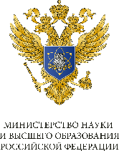 | 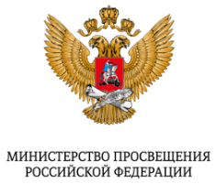 | 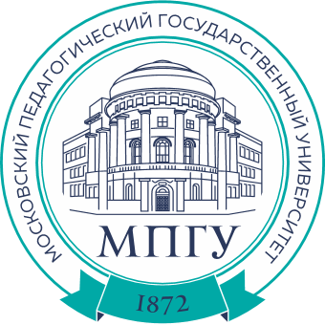 |  | 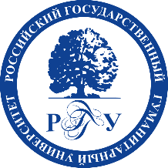 | 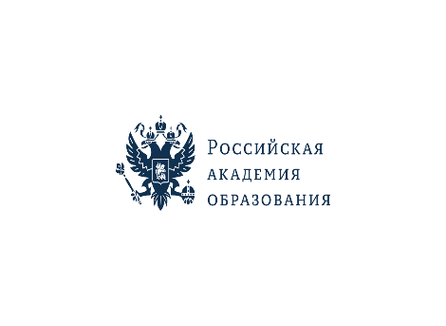

RUSSIAN ACADEMY OF EDUCATION
MOSCOW PEDAGOGICAL STATE UNIVERSITY
MOSCOW STATE UNIVERSITY OF PSYCHOLOGY AND EDUCATION
RUSSIAN STATE UNIVERSITY FOR THE HUMANITIES

THIRD INFORMATION LETTER

Dear Colleagues!
We invite you to participate in
the All-Russian Interuniversity Scientific and Practical Forum
with International Participation
“The Time of L.S. Vygotsky:
From Fundamental Theory to Contemporary Practice”

November 17–20, 2026, Moscow

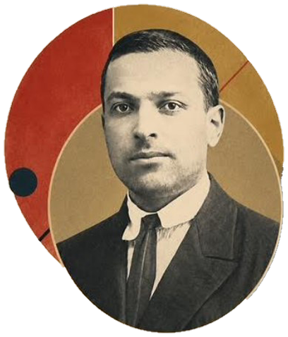
From November 17 to 20, 2026, the All-Russian Interuniversity Scientific and Practical Forum with International Participation “The Time of L.S. Vygotsky: From Fundamental Theory to Contemporary Practice” will be held to mark the 130th anniversary of Lev S. Vygotsky, an outstanding scholar, thinker, psychologist, and educator, and the founder of the cultural-historical school of thought.
The Forum aims to foster broad discussion of the contribution of L.S. Vygotsky’s ideas to Russian and international educational and psychological science, including an analysis of current trends in the development of the cultural-historical school and the possibilities for applying its fundamental principles in practice to address current challenges in the social sphere and education.
Forum Organizers:
Russian Academy of Education
Moscow Pedagogical State University
Moscow State University of Psychology and Education
Russian State University for the Humanities

Forum Organizing Presidium:
Olga Yu. Vasilyeva, Doctor of History, Professor, Academician of the Russian Academy of Education, President of the Russian Academy of Education
Andrey V. Loginov, Doctor of Political Science, Professor, Rector of the Russian State University for the Humanities
Alexey V. Lubkov, Doctor of History, Professor, Academician of the Russian Academy of Education, Rector of Moscow Pedagogical State University
Arkady A. Margolis, PhD in Psychology, Professor, Rector of Moscow State University of Psychology and Education

Chair of the Program Committee:

Vitaly V. Rubtsov, Doctor of Psychology, Professor, Head of the UNESCO Chair “Cultural-Historical Psychology of Childhood,” President of Moscow State University of Psychology and Education, Academician of the Russian Academy of Education

Forum Partners:

National League of Speech Therapists Association

Maxim Tank Belarusian State Pedagogical University (Belarus)

Contribution to the Future Charitable Foundation

G.E. Sukhareva Scientific and Practical Center for Mental Health of Children and Adolescents of the Moscow Department of Health

Institute of Education, HSE University

University of Cape Town (South Africa)

Makhambet Utemisov West Kazakhstan University (Kazakhstan)

Sirius University of Science and Technology

Federation of Educational Psychologists of Russia

Project Office of the “UchimZnaem” Hospital Schools Project

Deti.msk.ru Regional Charitable Public Foundation for Seriously Ill and Disadvantaged Children

Union of Mental Health Professionals

Institute of Special Education

Institute of Developmental Physiology, Health and Adaptation of Children

Artek International Children’s Center

Herzen State Pedagogical University of Russia

Federal Medical-Biological Agency of Russia

Federal University of Rio de Janeiro (Brazil)

Vertikal Chess Club named after the 10th World Chess Champion B.V. Spassky (Satka, Chelyabinsk Region)

Forum Venues:

November 17

Moscow Pedagogical State University, 1/1 Malaya Pirogovskaya St., Moscow
(Venue Coordinator: Tatiana N. Sakharova, Director of the Institute of Pedagogy and Psychology, Moscow Pedagogical State University; tn.sakharova@mpgu.su)

Registration is required via the following link: https://forms.yandex.ru/u/6a0af24f1f1eb5a5255a759f

Plenary Session of the Conference “Cultural-Historical Psychology: From Science to Social Practice,” 10:00–16:30

Round Tables 16:40-18:20:

Interdisciplinary Studies of the Child and Adolescent Brain in the Context of the Development of Cultural-Historical Theory

Play as the Leading Activity in Preschool Childhood: Historical Retrospective and Contemporary Transformations

One Hundred Steps in the Development of Russian Defectology: From Teacher Training to the Formation of an Independent Interdisciplinary Field

Development of L.S. Vygotsky’s Ideas in the Practice of Hospital Pedagogy

L.S. Vygotsky’s Psychology of Art: From Theory to the Practice of Training Art Teachers, Designers, and Decorative and Applied Arts Professionals

Psychological and Educational Support for Adolescents in the Zone of Proximal Development: The Experience of a Children’s Camp

The Scholarly Legacy of the Vygodsky Family and the Works of L.S. Vygotsky in University Library Collections

Open Lecture “Lev Vygotsky: Sketches for a Portrait,” 18:30–19:30

Maxim E. Osipov, PhD in Psychology, Associate Professor, Department of General Psychology, L.S. Vygotsky Institute of Psychology, Russian State University for the Humanities.

November 18

Moscow State University of Psychology and Education, 29 Sretenka St., Moscow
(Venue Coordinator: Sergey G. Kosaretsky, Vice-Rector for Research, Moscow State University of Psychology and Education; kosaretskijsg@mgppu.ru)

Registration is required via the following link:

https://forms.yandex.ru/u/6a4f67f31f1eb5590a30bd37

International Symposium under the auspices of the Commission of the Russian Federation for UNESCO “Inclusive Education: From L.S. Vygotsky’s Ideas to Contemporary Practices,” 10:00–18:30

Symposium “L.S. Vygotsky and Chess,” 9:00–12:20

International Discussion Platform “Problems Posed by L.S. Vygotsky,” 15:30–18:30
- Round Table “Improving the System of Psychological Support for Families with Children in the Historical and Border Regions of the Russian Federation: Best Practices,” 15:30–18:30

Rock Symphony Tale “Ruslan and Lyudmila,” performed by the inclusive theater “Nash Balaganchik,” Artistic Director — Natalia Shumilkina, a project of the Deti.msk.ru Foundation (Vishnevy Sad Moscow Theater Center, 10 Malaya Sukharevskaya Sq., Moscow), 19:00–20:30

Russian Academy of Education, 8 Pogodinskaya St., Moscow
(Venue Coordinator: Viktor S. Basyuk, Vice-President and Academician of the Russian Academy of Education; basyuk.victor@raop.ru)

Registration is required via the following link: https://forms.yandex.ru/cloud/6a3e589002848f002f39ec77

Symposium “Cultural-Historical Psychology: From Science to Social Practice,” 11:00

November 19

Russian State University for the Humanities, 6 Miusskaya Sq., Moscow
(Venue Coordinator: Oksana V. Markovskaya, Dean of the Faculty of Psychology and Deputy Director of the L.S. Vygotsky Institute of Psychology, Russian State University for the Humanities; markovskaya.ov@rggu.ru)

Registration is required via the following link:

https://forms.yandex.ru/cloud/6a5dee2902848fc29ad77199/

Opening of the International Scientific Readings in Memory of L.S. Vygotsky “Time and Space of the Cultural-Historical Approach” (Russia National Centre, 14 Krasnopresnenskaya Embankment, Moscow), 11:00–12:30

Opening of the L.S. Vygotsky Memorial Office and Exhibition, 13:30–14:00

Plenary Session, 14:15–17:00

Discussion of the Historical Feature Film “Vygotsky,” 17:30–19:00

November 20

Sirius University of Science and Technology, 1 Olimpiysky Ave., Sirius Federal Territory
(Venue Coordinator: Kristina M. Abdallah; slk.conference@talantiuspeh.ru)

Registration is required via the following link:

https://forms.yandex.ru/cloud/6a43aacc6d2d73c9d3074905

Scientific and Practical Conference “Agency of the Individual and the Collective: Issues of Research and Development”

Main Conference Topics:

1. Contemporary Research on Agency as a Psychological and Educational Category.

2. Activity-Based Approach in Education: The Role of Project, Research, and Work Activities in the Development of Agency.

3. Development of Agency in Ontogenesis.

4. Traditions and Contemporary Practices in the Development of Collective Agency.

5. The Role of Teachers and Mentors in the Development of Individual and Collective Agency.

6. Agency as a Factor in Readiness for Professional Self-Determination.

7. Cultural-Historical Psychology in the Research of Early-Career Scholars.

Moscow State University of Psychology and Education, 29 Sretenka St., Moscow
(Venue Coordinator: Sergey G. Kosaretsky, Vice-Rector for Research, Moscow State University of Psychology and Education; kosaretskijsg@mgppu.ru)
Registration is required via the following link:
https://forms.yandex.ru/u/6a4f883d5056906160990fb6

Strategic Session “Psychological and Educational Support for Participants in Educational Relations: Independent Expert Evaluation and a System for Disseminating Best Practices,” 11:00–17:00

Symposium “Mental Health in the Digital Age from the Perspective of Cultural-Historical Psychology,” 10:00–19:00

Round Table “Davydov Readings,” 10:00–14:00
- Round Table “AI as a (Non-)Significant Other: What Is Changing in Collaborative Learning Activities and Communication,” 16:00–18:00

Moscow School No. 1861 “Zagorye,” 14/1 Yagodnaya St., Moscow
(Venue Coordinator: Irina N. Vorobyeva, Senior Lecturer, Department of Psychological Anthropology, Moscow Pedagogical State University; vorobeyva@mail.ru)

Practice-Oriented Session “Addressing Educational and Developmental Tasks Based on the Theoretical Principles of L.S. Vygotsky’s Cultural-Historical Psychology,” 9:00–13:00

Registration is required via the following link: https://forms.yandex.ru/cloud/6a58f7ec02848f3c4ed770ee/

Dmitry Rogachev National Medical Research Center of Pediatric Hematology, Oncology and Immunology, 1 Samory Mashela St., Moscow
(Venue Coordinator: Ivan Yu. Doluev, Deputy Head of the “UchimZnaem” Russian Hospital Schools Project; doluev.iy@uchimznaem.ru)

Tour of the Flagship Site of the “UchimZnaem” Hospital Schools Project, 13:00–14:30

Registration is required via the following link:

https://forms.yandex.ru/u/6a5f0fad493639e43d4296aa

V.I. Vernadsky School No. 1553, 5 Khavskaya St., Moscow
(Venue Coordinator: Alexey S. Obukhov, Leading Expert, A.A. Pinsky Center for General and Extracurricular Education, Institute of Education, HSE University; aobuhov@hse.ru)

Round Table “Developing Students’ Research Activities as a Practice of ‘Maturing the Freedom to Act at Will,’ 12:00”

Registration is required via the following link:

https://forms.yandex.ru/u/6a58ef345056903fe0a0957e/

Institute of Developmental Physiology, Health and Adaptation of Children, 8 Gorodskaya St., Moscow
(Venue Coordinator: Elena N. Pristupa, Director of the Institute of Developmental Physiology, Health and Adaptation of Children, Professor at the Institute of Pedagogy and Psychology, Moscow Pedagogical State University; info@irzar.ru)

Round Table “Developing Independence and Responsibility in Children within the General Education System,” 11:00

Registration is required via the following link:

https://digital.irzar.ru/the-round-table/

Institute of Psychology, Herzen State Pedagogical University of Russia, online
(Venue Coordinator: Svetlana A. Bezgodova, Associate Professor, Department of Psychology of Professional Activities and Information Technologies in Education, Herzen State Pedagogical University of Russia; sbezgodova@herzen.spb.ru)

Round Table “Vygotsky’s Cultural-Historical Approach to the Development of Preschool Children in a Multicultural Environment,” 14:00–16:00

Registration is required via the following link: https://forms.yandex.ru/u/6a310cabf47e731d7750018a/

Russian State University for the Humanities, 6 Miusskaya Sq., Moscow
(Venue Coordinator: Oksana V. Markovskaya, Dean of the Faculty of Psychology and Deputy Director of the L.S. Vygotsky Institute of Psychology, Russian State University for the Humanities;markovskaya.ov@rggu.ru)

Registration is required via the following link:

https://forms.yandex.ru/cloud/6a5dee2902848fc29ad77199/

Round Tables, 11:00–14:00 (parallel sessions):

Round Table “The Concept of Cultural Development in Light of L.S. Vygotsky’s Ideas: Methodological Challenges of the Construct and Its Heuristic Potential”

Round Table “The Biosocial Problem in Psychology: From Theory to Practice”

Round Table “Cultural-Historical Psychology and Psychoanalysis”

Round Table “Interdisciplinary Research in Neuropsychiatry and Psychology” (in collaboration with the N.N. Burdenko National Medical Research Center for Neurosurgery)

Round Table “The Speech Therapy Dimension of the Legacy of the Cultural-Historical Approach”

Round Table “Psychology of Art and Psychological Aesthetics”

Round Table “Christian Psychology in the Contemporary Context”

Sections, 16:30–19:00 (parallel sessions):

Section “Cultural-Historical Neuropsychology and Pathopsychology”

Section “Personality and Society from the Perspective of Cultural-Historical Psychology”

Section “The Cultural-Historical Approach in Psychodiagnostics”

Section “Cultural-Historical Psychology of Education”

Section “The Cultural-Historical Approach in Family and Child Psychology”
- “Theater Practice in the Context of the Cultural-Historical Approach,” 14:30–16:00
Meeting with director Andrey Afonin and members of the Krug II Professional Special Theater.

Additional information about the program is available on the Forum’s official website.

Official website: https://vremyavygotskogo.ru/

Forum Activities:

Plenary presentations

Participant presentations and talks

Open discussions

Round tables

Workshops

Format: hybrid (in-person and remote participation, with online broadcasts).

Participation Options:
- Presenter with an abstract published in the Forum proceedings.
- Presenter without an abstract published in the Forum proceedings.
- Attendee with an abstract published in the Forum proceedings.
- Attendee without publication.

Conditions for Participation in the Forum:
To participate in Forum events, participants must register using the links provided in the respective event descriptions.

Applications to participate in the Forum as a presenter will be accepted through September 30, 2026 (inclusive).

Applications to participate in the Forum as an attendee without publication will be accepted through November 10, 2026 (inclusive).

Abstracts for publication in the Forum proceedings will be accepted through September 30, 2026 (inclusive).

Abstracts should be submitted by email to vremyavygotskogo@yandex.ru.
The subject line should include the full name of the author (the corresponding author, in the case of multiple authors) and the title of the Forum event. Example: “Ivanov I.I._L.S. Vygotsky and Psychology of Education Today.”
Abstracts must be prepared in accordance with the requirements specified in Appendix 1.
Abstracts must not have been previously published or submitted for publication elsewhere.
Compilation-based papers and papers consisting solely of summaries of existing research will not be considered. Literature reviews must be analytical in nature and should compare different authors’ perspectives on the issue under study, identify aspects that remain unexplored, and substantiate possible directions for further research.
The decision to include an abstract in the Forum proceedings is made by the Forum Program Committee. The Program Committee reserves the right to reject abstracts that do not correspond to the conference topics or materials that do not comply with the requirements set out in this Information Letter and the requirements for scientific publications.
By submitting an abstract, you confirm your consent to its publication in the Forum proceedings and its inclusion in the Russian Science Citation Index (RSCI) / Science Index database.

All participants will receive certificates.
There is no registration fee for participation in the Forum.
Publication of abstracts is free of charge.
Travel, accommodation, and meal expenses during the Forum are to be covered by the participants’ sending organizations.

Organizing Committee Contacts:
E-mail: vremyavygotskogo@yandex.ru
Scientific Secretary: Andrey V. Konokotin, PhD in Psychology.

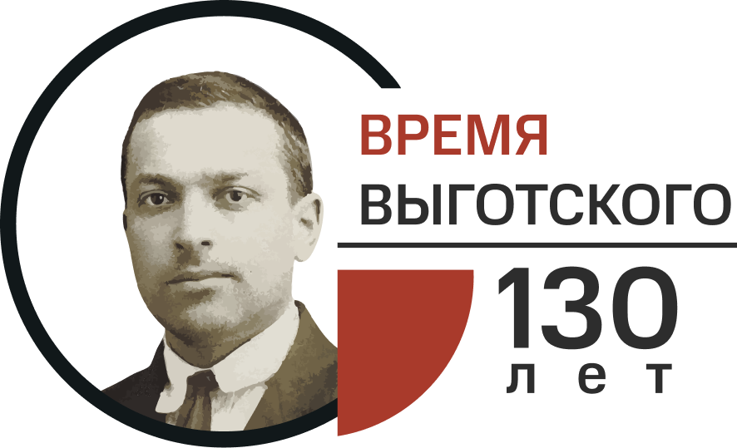

Appendix 1. Abstract Formatting Requirements

- The text should be formatted in Times New Roman, 12 pt, with 1.0 line spacing. Margins: top and bottom — 20 mm; left and right — 24 mm.
- Figures and graphs must be clear and legible.
- Equations must be prepared using the built-in MS Equation Editor. Manual hyphenation should be avoided.
- Abstracts must include the following information:
  - title of the paper (on a new line, centered and in bold, no more than 100 characters);
  - on the next line, right-aligned and in italics — surnames and initials of all authors, separated by commas (surname first for each author);
  - on the next line, right-aligned and in italics — current academic title and position;
  - on the next line, right-aligned and in italics — abbreviation of the university / institute / center /…, city, country;
  - on the next line, right-aligned — e-mail address (with the author’s consent).
- Abstracts must not exceed 3 A4 pages, including author information and references.
- References should be formatted in accordance with the bibliographic guidelines and requirements for scientific publications: (https://psyjournals.ru/manuscript_submission/homestyle_guide/requirements#refs).
- Any abbreviations, except for units of measurement, may be used in the text only after the term has first been given in full.

Example of Abstract Formatting:

The Social Situation of Adolescent Development in the Digital Age

Ivanov S.P.
Associate Professor, Faculty of Psychology of Education
Moscow State University of Psychology and Education (MSUPE), Moscow, Russia
In the context of the widespread digitalization of contemporary society, the use of computer technology as a means of delivering software and information systems is becoming increasingly important in organizing the educational process at different levels.

References
- Elkonin, D.B., Dragunova, T.V. (1967). Age and individual characteristics of younger adolescents. Moscow: Prosveshchenie. (In Russ.)

