THEORETICAL RESEARCH: pp. 1–2

EMPIRICAL RESEARCH: pp. 3–5

THEORETICAL RESEARCH

Activity Experience of First-Year Students

Vitalyi N. Ivanov
Saint Petersburg State University, Saint Petersburg, Russia
ORCID: https://orcid.org/0000-0002-0777-1111, e-mail: ivanov@yandex.ru

Vladimir N. Petrov
Moscow State University of Psychology & Education, Moscow, Russia
ORCID: https://orcid.org/0000-0002-0777-1122, e-mail: petrov@yandex.ru
Objective. Analysis of the correlation between concepts “cyberspace”, “computer virtual reality”, “computer interactive environment”, “interactive experience”; wording of the author’s definition of the term “psychological virtual reality”; identification of its functions and features .
Background. Computer interactive environments are becoming the main platforms for the professional and personal self-realization of a modern person, the social activity of youth is shifting to the Internet space, models and forms of interpersonal interaction and communication are changing, new psychological constructs are formed that reflect virtual world and provide interaction with it. Psychological virtual reality acts as an intermediary between a person as a personality and a computer interactive environment as a form of cyberspace representation in modern human life, and the psychological constructs generated in it determine the formation of new socio-psychological behavior patterns.
Methodology. Systemic and subjective approaches, comparative analysis method.
Conclusions. The creation of computer interactive environments has opened a new stage in the formation of a new interactive human experience as a system of information technology and socio-psychological competencies. There is a need for a systematic study of the conceptual-categorical apparatus that is used to describe computer interactive environments.
Keywords: computer virtual reality; cyberspace; psychological virtual reality; computer interactive environment; virtual socialization; psychotypes of virtual reality subjects; personal virtual space.

Funding. The reported study was funded by Russian Science Foundation, project number 00-00-00000, https://rscf.ru/en/project/00-00-00000/ at the Southern Federal University.
Acknowledgements. The authors are grateful for assistance in data collection Ivanov T.Yu.

For citation: Ivanov V.N., Petrov V.N. Activity Experience of First-Year Students. Sotsial'naya psikhologiya i obshchestvo = Social Psychology and Society, 2020. Vol. 11, no. _, pp. _–_. DOI: https://doi.org/10.17759/sps.2020110__

Introduction

Text here...

The main sections of the article

Text here...

Conclusions

Text here...

References
- Babbie E. Survey Research Methods 2nd Ed. Belmont, Calif: Wadsworth, 1990. 395 p.
- Blair C. How similar are fluid cognition and general intelligence? A developmental neuroscience perspective on fluid cognition as an aspect of human cognitive ability. Behavioral Brain Science, 2006. Vol. 29, no. 2, pp. 109–125. DOI:10.1017/S01405 25X06009034
- Gerrard M., Gibbons F.X., Bushman B.J. Relation Between Perceived Vulnerability to HIV and Precautionary Sexual Behavior [Electronic resource]. Psychological Bulletin, 1996. Vol. 119, Issue 3, pp. 390–409. Psychological Association, Inc. URL: https://psycnet.apa.org/journals/bul/119/3/390.html?uid=1996-01402-004 (Accessed 10.03.2021)

Information about the authors
Vitalyi N. Ivanov, PhD in Psychology, Leading Research Associate, Associate Professor, Chair of Psychology, Saint Petersburg State University, Saint Petersburg, Russia, ORCID: https://orcid.org/0000-0002-0777-1111, e-mail: ivanov@yandex.ru
Vladimir N. Petrov, PhD in Psychology, Leading ResearchAssociate, CenterofApplied Psychological Studies, Moscow State University of Psychology & Education, Moscow, Russia, ORCID: https://orcid.org/0000-0002-0777-1122, e-mail: petrov@yandex.ru
Получена __.__.202_ | Received __.__.202_
Принята в печать __.__.202_ | Accepted __.__.202_

EMPIRICAL RESEARCH

Activity Experience of First-Year Students

Vitalyi N. Ivanov
Saint Petersburg State University, Saint Petersburg, Russia
ORCID: https://orcid.org/0000-0002-0777-1111, e-mail: ivanov@yandex.ru

Vladimir N. Petrov
Moscow State University of Psychology & Education, Moscow, Russia
ORCID: https://orcid.org/0000-0002-0777-1122, e-mail: petrov@yandex.ru

Objective. Analysis of the relationship between social beliefs, political trust and readiness to participate in normative and non-normative forms of political actions.
Background. Amid growing politicization of citizens in different countries, the demand for an analysis of factors linked to the readiness of citizens to participate in various forms of political activity, from voting to street protests, is increasing. It is extremely important to identify universal and culturally specific factors that influence political behavior.
Study design. The study examined the relationship between social beliefs, political trust, and readiness to participate in political activity. The presence and nature of the relationship was verified through correlation analysis and structural equation modeling (SEM).
Participants. Russian sample: 440 people (76.4% of men, 23.4% of women) from 23 to 77 years old (M = 38.99; SD = 11.62). Ukrainian sample: 249 people (59.8% of men and 40.2% of women) from 23 to 65 years old (M = 35.55; SD = 10.76).
Measurements. Russian-language versions of the scales of Belief in a dangerous world by J. Duckitt and Belief in a just world by C. Dalbert. Author's scale of political trust and readiness to participate in political activity.
Results. Belief in a just world increases political trust; belief in a dangerous world reduces it. Political trust positively predicts readiness to participate in various forms of normative political activity. The presence of cross-cultural differences in the characteristics of the model between the Russian and Ukrainian samples is established.
Conclusions. There is a significant relationship between social beliefs, political trust and readiness to participate in various forms of political activity.
Keywords: activity-related experience; quality of motivation; self-determination theory; intrinsic motivation; extrinsic motivation; academic motivation.

Funding. The reported study was funded by Russian Science Foundation, project number 00-00-00000, https://rscf.ru/en/project/00-00-00000/ at the Southern Federal University.
Acknowledgements. The authors are grateful for assistance in data collection Ivanov T.Yu.
For citation: Ivanov V.N., Petrov V.N. Activity Experience of First-Year Students. Sotsial'naya psikhologiya i obshchestvo = Social Psychology and Society, 2020. Vol. 11, no. _, pp. _–_. DOI: https://doi.org/10.17759/sps.2020110__

Introduction

Text here...
Methods

Text here...

Results

Text here...

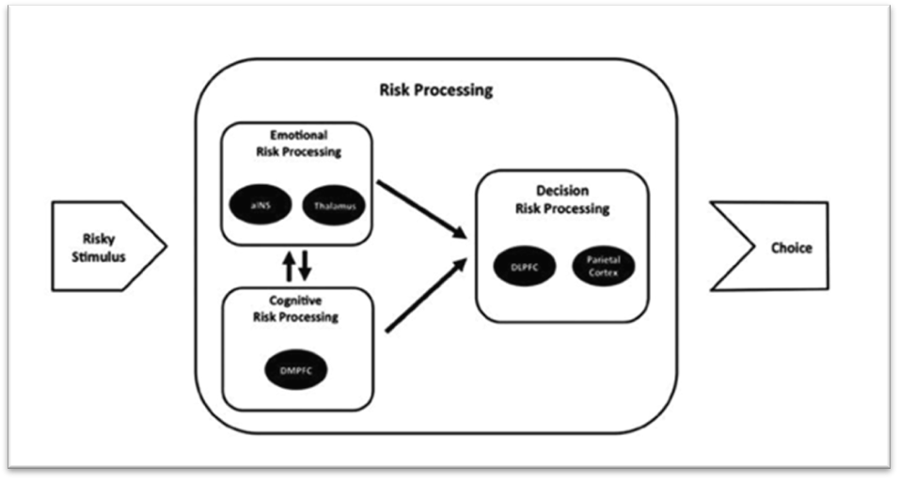

Fig. 1: Risk Processing Mechanism

Table 1

Descriptive statistics and zero-order correlations between (a) components of the TriRisk model, perceived severity, benefits, barriers, and Fatalism; and (b) compliance behavior

Variables | Mean | SD | 1 | 2 | 3 | 4 | 5 | 6 | 7 | 8
1. Compliance  Behavior | 60,78 | 9,41 | – | 0,21** | 0,41** | 0,24** | 0,08 | 0,15** | –0,28** | –0,10*
2. Deliberative | 5,6 | 1,30 |  | – | 0,46** | 0,36** | 0,15** | 0,11* | –0,09 | –0,15**
3. Experiential | 4,45 | 0,75 |  |  | – | 0,55** | 0,17** | 0,27** | –0,10* | –0,17**
4. Affective | 12,03 | 2,07 |  |  |  | – | 0,20** | 0,30** | –0,02 | –0,21**

Note: **p < 0.01, * p < 0.05.
Discussion

Text here...

Conclusions

Text here...

References
- Babbie E. Survey Research Methods 2nd Ed. Belmont, Calif: Wadsworth, 1990. 395 p.
- Blair C. How similar are fluid cognition and general intelligence? A developmental neuroscience perspective on fluid cognition as an aspect of human cognitive ability. Behavioral Brain Science, 2006. Vol. 29, no. 2, pp. 109–125. DOI:10.1017/S01405 25X06009034
- Gerrard M., Gibbons F.X., Bushman B.J. Relation Between Perceived Vulnerability to HIV and Precautionary Sexual Behavior [Electronic resource]. Psychological Bulletin, 1996. Vol. 119, Issue 3, pp. 390–409. Psychological Association, Inc. URL: https://psycnet.apa.org/journals/bul/119/3/390.html?uid=1996-01402-004 (Accessed 10.03.2021)

Information about the authors
Vitalyi N. Ivanov, PhD in Psychology, Leading Research Associate, Associate Professor, Chair of Psychology, Saint Petersburg State University, Saint Petersburg, Russia, ORCID: https://orcid. org/0000-0002-0777-1111, e-mail: ivanov@yandex.ru
Vladimir N. Petrov, PhD in Psychology, Leading ResearchAssociate, CenterofApplied Psychological Studies, Moscow State University of Psychology & Education, Moscow, Russia, ORCID: https:// orcid.org/0000-0002-0777-1122, e-mail: petrov@yandex.ru
Получена 04.01.2020 | Received 04.01.2020
Принята в печать 30.02.2020 | Accepted 30.02.2020

